Linked View

For this task I was given an Access database which is linked to a view in ProMonitor and ProSolution. The aim of the database is to report on all courses and the lecturers that teach them. This task would help my colleague (Joanne Patterson) with her report to the head of English and Maths. Before I started doing the task previous work had been done by Michael Thuburn. He imported ProAchieve and ProSolution data from SQL Server into Access using linked views. The Access Objects were:

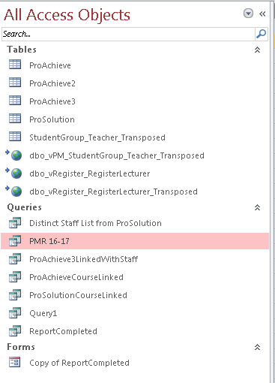

As it can be seen from the picture above there are 3 tables called ProAchieve. For the purpose of this report we will be using ProAchieve3 because it holds data about courses that are taught in Academic Year 17/18. The problem that Joanne is currently having is that she is not sure that the table named ProSolution holds information about all the lecturers going for 16/17 and 17/18, mainly because ProSolution does better reporting on current staff.

After a small discussion with Michael we decided to use a view which can be found on the Server USSQL01/ProMonitor named vSearch_StudentGroup_Teacher which after closer investigation we realised that it might hold information about all of the courses and staff going back to 14/15.

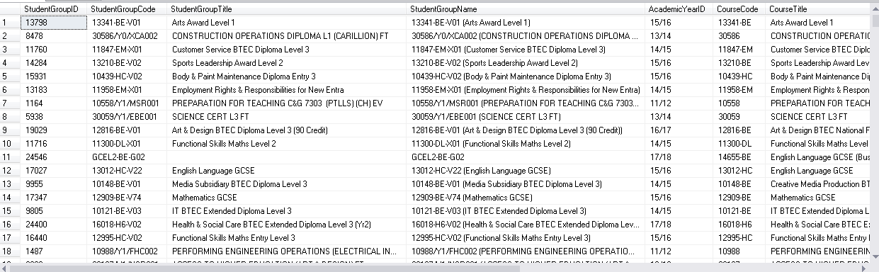

Since the ProSolution table was coming from a view which had the following code.

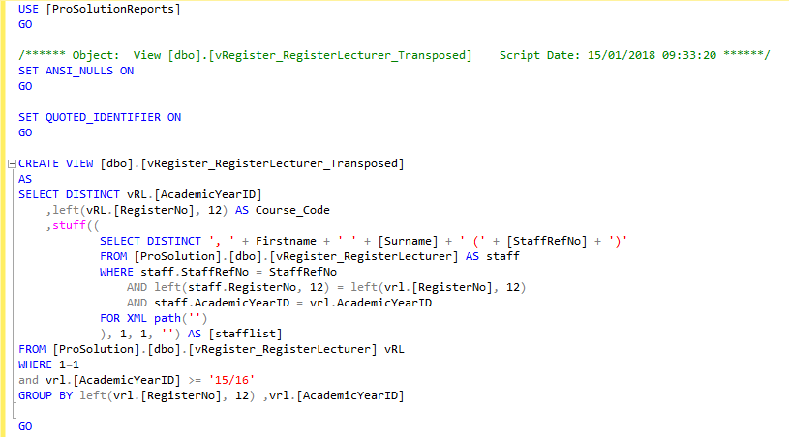

The query helps to create a view but also separates the year from the student group code taking only the first 12 characters. The stuff function concatenates the first and last name of the lecturers as well as their StaffRefNo and puts all the lecturers teaching a course to be displayed on one row, separated by commas.

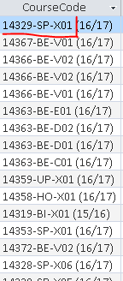

After a small discussion with Joanne and Michael we came to the conclusion that not all lecturers were there so we needed to use another table or view to retrieve the information that we wanted.

Luckily Michael and I found a view on USSQL01/ProMonitor/DBO/vSearch_StudentGroup_Teacher which had all of the data that we wanted going back to 14/15. However, in order to use the view I had to move it into another database USSQL01/ProMonitorReproting/DBO/vSearch_StudentGroup_Teacher.

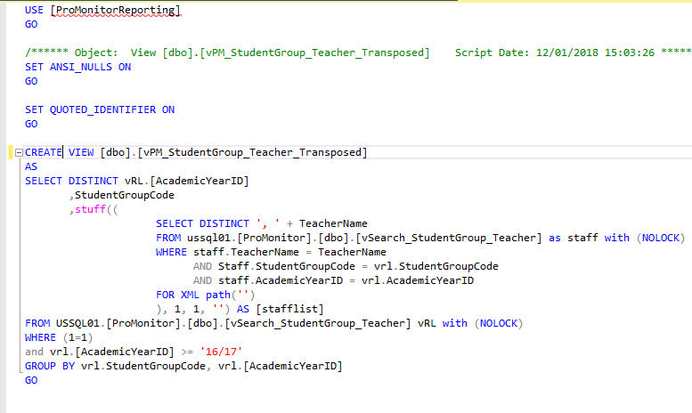

I have slightly reworked the old code in order to make the view do want I want precisely. I have also used with (NOLOCK) because I just want to scan through the data I do not want to lock it and other people would not be able to update it.

After creating the view, I had to go into access and link the view to the database which can easily be done by following these steps:

1. On the top menu go to the tab **External Data**

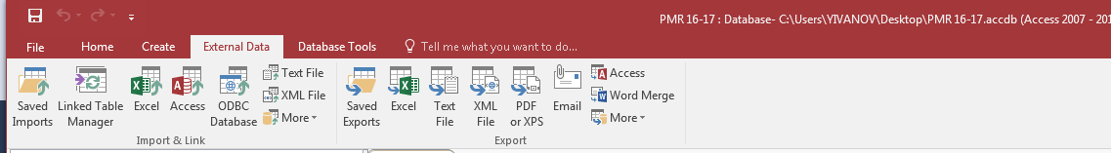

1. Click on **ODBC Database**

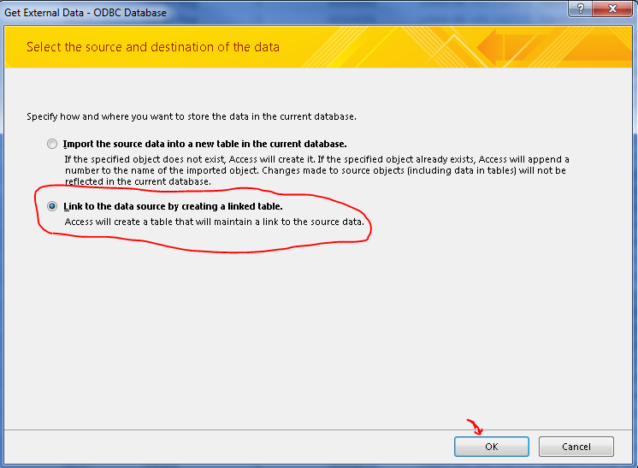

1. On the next screen create a new ODBC Connection and give it a name.

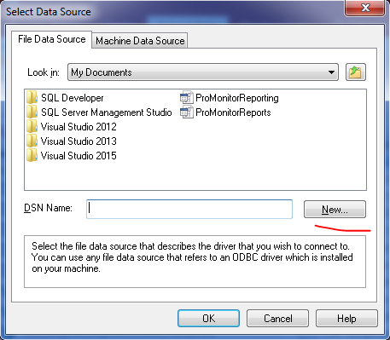

1. After clicking New… that would bring up a window asking you to specify the type of the Data Source.

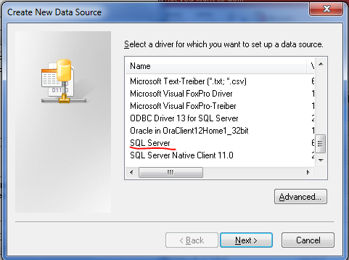

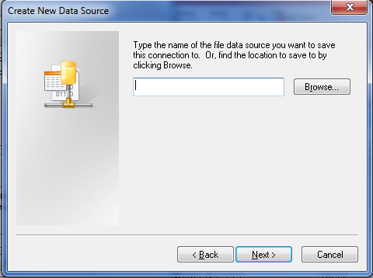

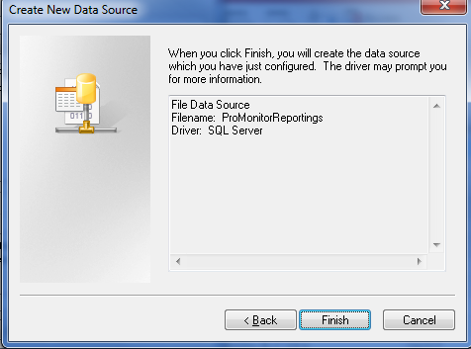

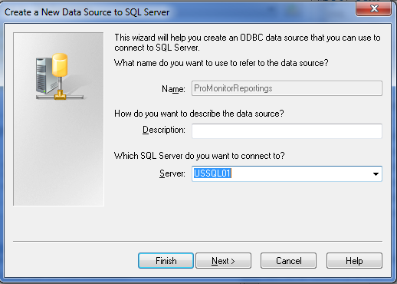

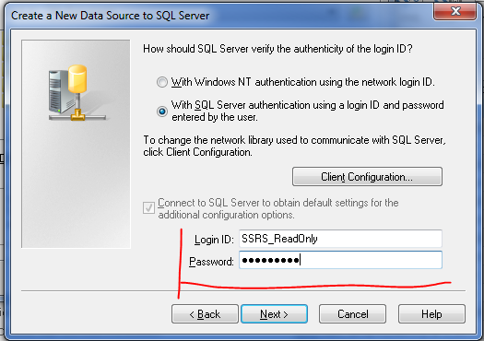

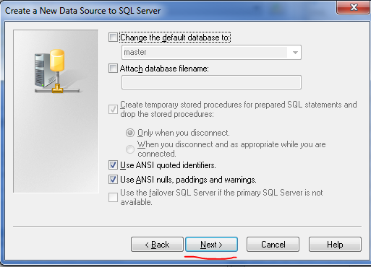

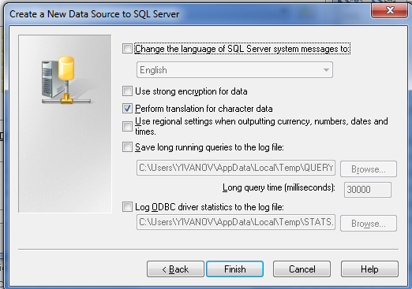

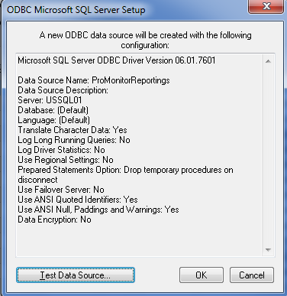

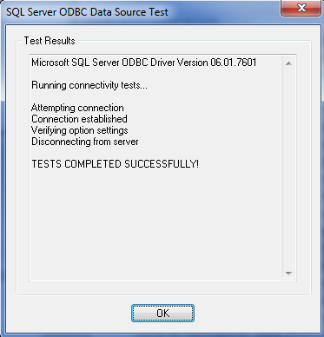

After creating the database I created a linked view which I named dbo_vPM_StudentGroup_teacher_Transposed and linked the data from ProAcheive to ProSolution. Having this link with the view from ProSolution ensures that the data will always be updated.

The final query that I wrote in access is:

